

Content Management & Generation System


Project Overview

ACM SIGSOFT publishes a bi-monthly hybrid Newsletter called Software Engineering Notes (SEN). The Newsletter is manually assembled by the editor, Dr. Will Tracz who receives various contributions from established column editors and other contributors who submit documents in various forms and formats. The print copy is a single pdf file. The digital copy is rendered from the single pdf file and enhanced with additional pdf files, after the necessary metadata is manually extracted. In addition, a table of contents is manually created for each issue. Last year a team of RIT students named Team SEND created a partial solution for alleviating some of the manual portions of newsletter creation. Their efforts resulted in a basic content submission capability but the composition capability was never completed.

The system has two main components: submission and composition. Team SHARP will focus on the composition component while modifying the existing submission component to be more robust. The submission component will need to be re-evaluated and re-engineered for improvements which include usability and modification to ensure a more seamless workflow between the submission and composition components.

The parts to be developed as new functionality and part of the composition component will be the automatic composition of the table of contents, table of papers, table of reports and table of abstracts. The application will allow users of the system to submit content such as column articles, letters to the editor, and other such content. This content will be accompanied by metadata, which will be necessary to automate the construction of the newsletter. Once composed, these tables will be combined into a printable document for construction of the newsletter.

Basic Requirements

User Registration

Description and Priority
This Feature describes how the users will register and be managed.
Priority – Very High
Added in- Phase 1

Stimulus/Response Sequences
A user wants to register with the system and be able to login to use it.

Functional Requirements
REQ-1: A user must be able to register with the system
REQ-2: A user must be classified as a regular user, an editor, an administrator, or any combination of the three user types
REQ-3: Once registered, a user must be able to log into the system
REQ-4: A user must have privileges to access system content, based on their user status
REQ-5: A user must be able to reset their password
REQ-6: A user must be able to receive notifications and other messages from the editor

Security Requirements

SE-REQ-1: A user’s password must be encrypted using sha-1 hashing.
SE-REQ-2: Transactions which will deal with the password of the user will be handled only using the encrypted version of the password
SE-REQ-3: When resetting a user’s password, a confirmation email will be sent to their registered email account. The password will not be reset unless the confirmation email is responded to.

Administration

Description and Priority
This Feature describes what functionality administrators will have in the system
Priority – Very High
Added in- Phase 2

Stimulus/Response Sequences
An administrator would like to perform updates to users

Functional Requirements
REQ-1: An administrator must be able to grant editor status
REQ-2: An administrator must be able to revoke editor status
REQ-3: An administrator must be able to grant columnist status
REQ-4: An administrator must be able to revoke columnist status
REQ-5: An administrator must be able to remove a user from the system
REQ-6: An administrator must be able to revoke users’ privileges
REQ-7: An administrator must be able to grant editor status
REQ-8: An administrator must be able to grant administrator status
REQ-4: An administrator must be able to revoke administrator status
REQ-9: An administrator must be able to view a transaction log which will contain information for events happening in the system
REQ-10: An administrator must be able to clean up the transaction log from recent activity.
REQ-11: An administrator must be able to save a copy of the transaction log for their own records.

Document Submission

Description and Priority
This Feature describes how document submission will take place
Priority – High
Added in- Phase 1

Stimulus/Response Sequences
A user would like to submit content to the system

Functional Requirements
REQ-1: The user will be required to agree to terms and conditions before submitting any content
REQ-2: A user must be able to submit documents by uploading them. These documents include:
- columns
- letters to the editor
- papers
- reports
- book reviews
- calls for participation
- calls for papers
REQ-3: A user must be able to retract a submission
REQ-4: A user must be able to update a submission’s content
REQ-5: A user must be able to update metadata associated with the submission. Metadata includes:
- Author/authors
- Title
- Digital Identifier
REQ-6: A user must be granted columnist status in order to submit columns
REQ-7: A columnist must be notified when their column is due for submission
REQ-8: Document format support will include .docx and .txt file formats

Document Review

Description and Priority
This Feature describes how an editor can review documents
Priority – High
Added in- Phase 1

Stimulus/Response Sequences
An editor would like to review submissions.

Functional Requirements
REQ-1: An editor must be able to view all submissions in the system
REQ-2: An editor must be able to view submissions by category
REQ-3: An editor must be able to approve, reject, or comment on a submission
REQ-4: An editor must be able to download a submission in order to review it
REQ-5: An editor must be able to remind columnist to submit their entries
REQ-5: An editor must be able to message columnists; these messages will be delivered to the columnists via e-mail
REQ-6: An editor must be able to assign an issue number to a submitted document

Document Assembly

Description and Priority
This Feature describes how an editor can assemble documents. Normally, the editor receives submissions via email and assembles them manually into an issue. Part of this process is the editor creating a table of papers and a table of abstracts.

This feature attempts to alleviate the burden on the editor by automating the creation of the tables of papers and abstracts.

Priority – High
Added in- Phase 3

Stimulus/Response Sequences
An editor has viewed the submissions and wants to start assembling an issue

Functional Requirements
REQ-1: An editor must be able to select content to use for the issue
REQ-2: An editor must be able to order letters to the editor
REQ-3: An editor must be able to order calls for papers
REQ-4: An editor must be able to semi-generate a table of papers
REQ-5: An editor must be able to semi-generate a table of abstracts
REQ-6: An editor must be able to generate or enter a digital identifier for a paper

Constraints

Attribute | Required | Recommended
Platform | N/A | Windows 2003 Server
CPU | Minimal | Intel Pentium 4 2.33GHz, AMD Athlon™ 64 2800+ processor (or equivalent)
RAM | 512mb | 1024mb
Resolution | 1024 x 768 | 1600 x 1200
Java Runtime Environment (JRE) | JRE 1.6 or later | JRE 1.6 or later
Database | MySQL | MySQL 5.0
Application Server | Apache Tomcat or Glassfish | Apache Tomcat 6.x
Browser | Use any at your own risk | Internet Explorer 7.0/Firefox 3.x
Language | English | English
Internet Connection | Cable or DSL | Business Cable, T3 or higher
Javascript | Enabled | Enabled
OpenOffice UNO | Required | Required

Development Process

The development process our team used was a combination of iterative development and incremental delivery that was chosen by our team and approved by our sponsor.

The list of requirements given to us was broken down into three independent phases. This allowed our sponsor to view each phase after its release and provide us with feedback, which gave us with a method of tuning the requirements for the following phase(s). In addition, it allowed us to develop different phases concurrently when necessary.

After the requirements were agreed upon for each phase, the system was designed (or the design built upon) so all team members were aware of the relationships between different parts of the system and how the different parts would be developed. It also ensured that our system followed key design patterns (such as MVC) that we set out to use.

The implementation, integration, and testing for individual features within the system was assigned and carried out on an individual basis. Once all requirements were completed for a specific phase (i.e. features added), all work for the phase was integrated with the existing system (System Integration) and then tested again (System Testing) as a single unit.

Once system testing was complete for a specific phase, a pre-release version was made available for our faculty coach and sponsor to view and provide us feedback on. Work then began on the subsequent phase(s). When Phase 3 is complete, the sponsor will receive a release version of the system.

Project Schedule: Planned and Actual

Planned

Actual

The project schedule was just a concrete breakup of our process plan which split design and development into three separate phases for iterative and incremental delivery of the product. The team sat down and debated the challenge of each feature set and number of days/weeks for each sub-task within a phase was derived from this discussion. The actual schedule was fairly close to our plan, but document generation became a persistent slip for the schedule, knocking back delivery for a couple items after it. Document generation was expected to be half-way complete by start of Phase 3, but it was more like a quarter complete due to some setbacks we had as a team. Instead of taking a constant slip on the schedule, we essentially just moved the remaining document generation tasks outstanding in Phase 2 to Phase 3 development.

System Design

Architecture Patterns

Model-View-Controller

The model-view-controller architectural pattern will be used to provide a separation of concerns between the three major parts of the system: the user-interface, the business logic, and the data itself. The user-interface will act as the view and accept user input. These inputs will then be handled by servlets which act as the controller and communicate with the application layer, which acts as the system’s model. The user-interface will also use the model indirectly through the controller to customize itself when necessary.

Using the model-view-controller pattern will allow most of the development of the three major parts separately. It will reduce the impact of changes and help with integration.

Pipe & Filter

The pipe and filter architectural pattern will provide a method for separating the task of generating a table of papers and table of abstracts into separate steps. This allows each step of table generation to be developed separately and then integrated at the end as a sequence of steps resulting in the generation of a table. Following this pattern also improves maintainability and testability, as maintenance and testing can be performed on each step individually. This ensures each step works properly before it is integrated with the other steps.

Event-driven

The event-driven architectural pattern will be used to provide notifications to one or more relevant users should new users register with the system, a user uploads a document, an administrator approves or rejects a document, or an issue’s due date is near. Administrators will also have the power to send custom notifications through the user-interface at any time should they desire to do so. Notifications will be triggered either in response to some action or in response to the real world’s time and date passing the time and date specified on a notification. Therefore, events are triggered by either a user or a timer which are then processed by the system resulting in a notification being created and then sent out to one or more users via email.

Architecture Discussion

The system is built the way it is to maximize extensibility for future improvements. This was important as the key stakeholder was concerned about being able to create significant value by the end of the project deadline. Classes that process data are broken into pairs where each pair has a data holder class as well as a manager class that performs the logic associated with the data. Each servlet class is paired with a java server page in the web layer and handles one piece of functionality from the web layer that is passed down into the application layer for processing. Any class at the manager level may establish a connection to the database for persistence simply by statically invoking the DBConnection class. Due to all of these reasons, adding new vertical slices of functionality should be simplistic at worst.

As with most Information Systems, the Client Server pattern is used here due to the system running on one computer while many different people need to be able to access it from their own machines. The web based user interface allows for this, but this interface needs to be able to access proper information and perform necessary tasks. The Client Server pattern is an obvious choice for dealing with this issue as the pattern exists for this reason. The system’s application functionality runs on its own thread. Users log in with sessions storing their information, limiting their possible tasks based on user type. The users’ actions interact with the system, but neither the web-based portions nor the application layer portions depend on the other to work.

This was the architecture chosen due to the fact that the system required a three-tiered system like most typical enterprise web applications. The three layers that this system is using are a Web Layer, an Application Layer, and a Persistence Layer. The client is interacting through different servlets based on the action needed to be performed in the web layer. These servlets invoke managers in the Application layer which will modify, create, and interact with possible actions the user has invoked. Once the actions have been processed and data is required to go into the database the Application layer creates SQL commands, where data is sent to the database for storage.

The following workflow outlines all the major events and the main roles in the system and how the system works in general:

The original design and architecture for the system was modified slightly as the project persisted, but the vast majority of the original design was preserved and few changes were made. In fact, no major changes were made to the original design.

Process and Product Metrics

Slippage Chart

Since we used an incremental approach as our process, a slippage chart was kept to make sure we completed the tasks we deemed necessary to add value in each increment and release. We could show the number of days that we were ahead/behind schedule based on planned dates for reaching milestones. Each increment is a particular milestone to be reached. We identified target dates for reaching each milestone, tracked actual dates of reaching each milestone, and plotted the difference.

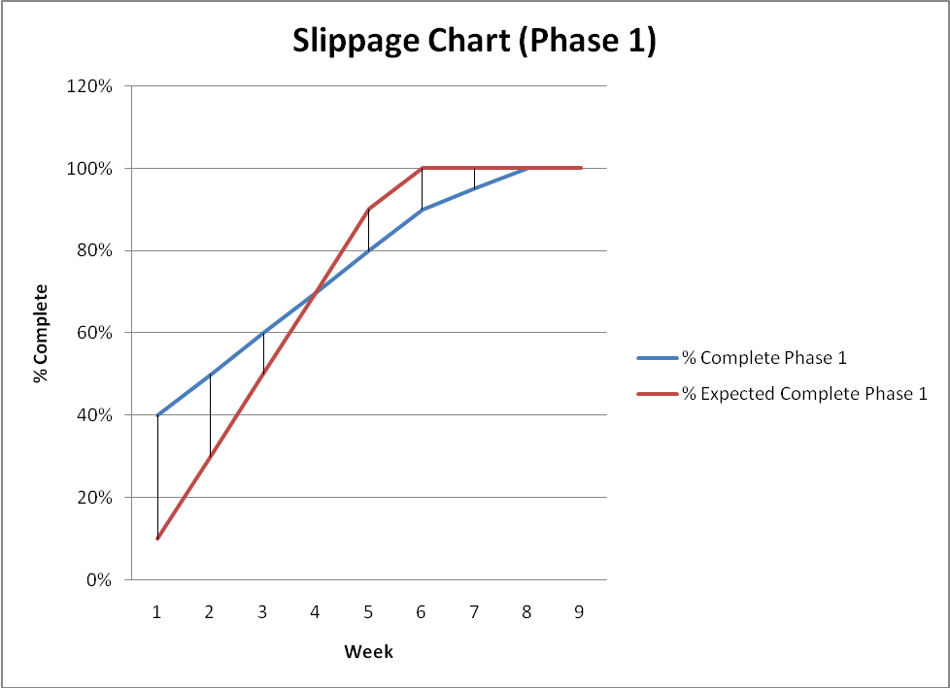

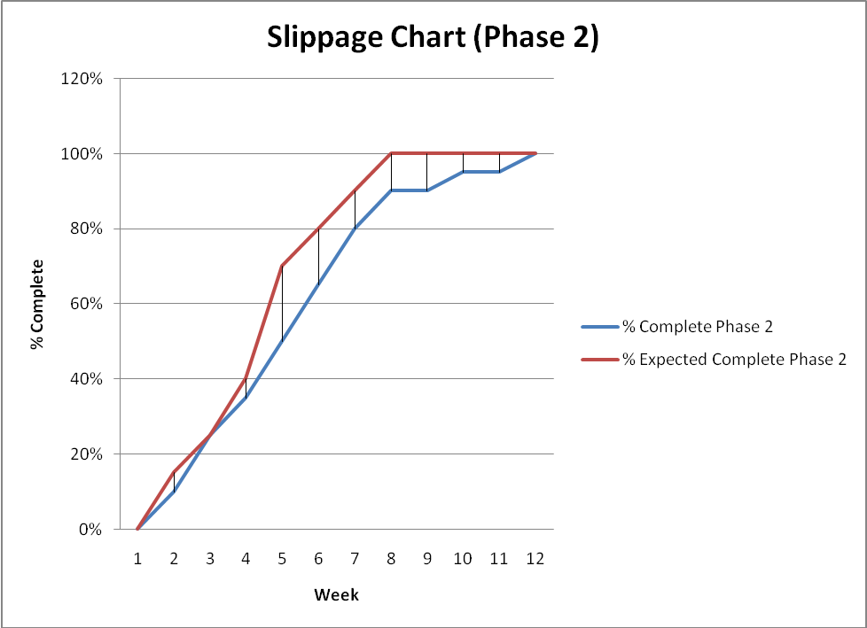

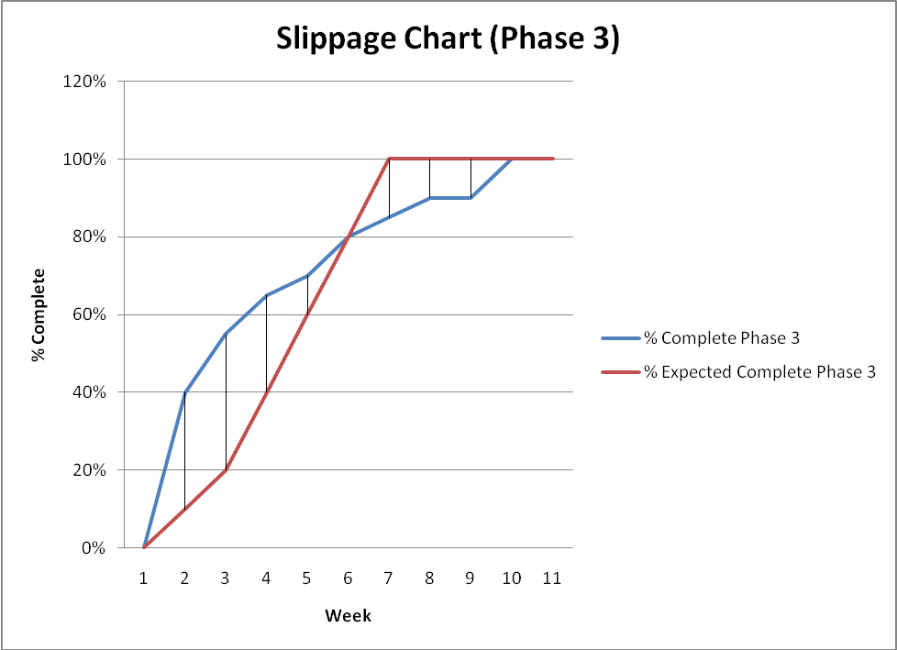

Productivity by Volume

After the completion of each week, the total lines of source code produced in a given week were recorded in a table and then compared to the previous week. In this way, we were able to chart our productivity in any given week.

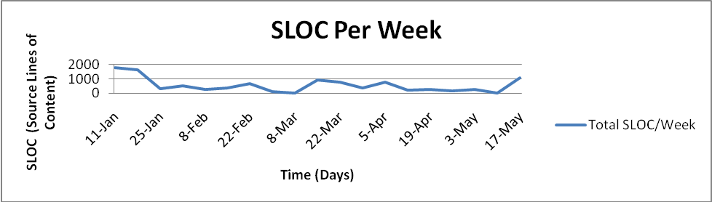

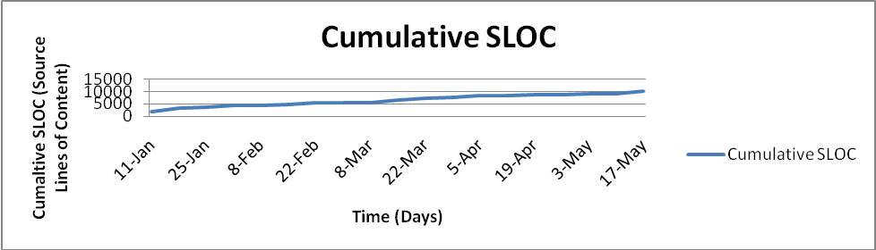

Results & Interpretation

The data gathered by the slippage charts and the total lines of source code indicates that our team was behind schedule most of the time, especially near the end of a phase, but highly productive in terms of producing content. Therefore, it is likely our team underestimated the difficulties and challenges that were part of our project and did not sufficiently plan for them. With better planning upfront, our team may have been able to address the difficulties and challenges of the project more easily (requiring less time and effort).

The metrics make it clear that our team did not plan sufficiently and therefore probably had to work much harder down the stretch than if we had planned things out and researched the project’s challenges more vigorously beforehand. However, the metrics also point out that our team was hardworking and very productive when it came to producing content.

Product State at Time of Delivery

The vast majority of the project was completed at time of delivery. All of the content management system is complete. Frontmatter and backmatter are generated automatically for newsletter editors based on accepted documents and volume/issue numbers. Once generated, the portions of the newsletter are immediately downloadable by an editor in word format. The remaining portions of the document that must be created manually are the columns and papers themselves as well as the table of contents.

The project was divided into 8 parts by the project sponsor. Listed below are those 8 items. Green means the item is complete, red means the item is not complete or not started, and blue means the item is partially complete.

1) Submission/Status – Develop a form to upload submissions to SEN by potential
contributors and allow them to review their status (and notify the editor, automatically
send an acknowledgement email, etc.)

2) Metadata Extraction/Collection – initially request manual entry of metadata (e.g.,
Title/Author/Affiliation) but eventually automatically extract metadata from submission

3) Workflow – a mechanism to trigger events associated with the time and status of
documents (e.g., send out reminders to column editors if they have not uploaded a
submission by a certain date). Initially workflows will be canned, but later may be
parameterized.

4) DL Content Insertion Preparation– create XML records necessary for entering Newsletter content into the ACM DL

5) Content Processing – generate PDF from various source formats

6) Newsletter Composition – combine contributions into single newsletter based on specific guidelines and add appropriate headers.

7) Newsletter Distribution – prepare a release package of all components to send to printer for publication

8) Newsletter Content Allocation – this potential feature will allow placement of content based on size, priority (e.g., move content order or move content to future issue)

Project Reflection

For the most part, everything went well with the project. Our design was solid enough in the beginning that the team did not need to stray from it the entire length of the project. We feel this is one of our biggest victories because any portion of the project that did not get completed is only due to the time constraints of the project, but without proper design the project would have been a failure no matter what. The actual product itself is another victory since we accomplished most everything we told our sponsor we would. Only a few areas were not fully completed, but those areas were cleared with our sponsor and the level that they have been completed was deemed adequate.
Nothing about our project went totally wrong, though we did have a setback with our Front-Matter and back-Matter generation systems. Originally, while we did assume this to be the hardest aspect of our system, we did not anticipate just how difficult it would be. Our initial plan had to be scrapped and we had to resort to a backup plan which was highly time-consuming. In the end everything did work out, however if we could go back and change something about our project I am sure we would have started on the generation systems earlier so that we could have had more time to redesign that portion of the system, or at the very least how it would be executed. Another thing we may have done differently is the type of research we did to determine which language to develop the system in. While research was done, it was not based on the hardest assumed aspects of the system, just on the system as a whole. Through our research we determined there to be no difference between the two choices we had narrowed it down to and so went with familiarity as the deciding factor. Had we researched specifically the generation portion of our system we may have made a different choice, or at the very least come up with a plan for that specific portion of the system.
We feel we have learned a great deal from this project. It has given us real world examples of how customer/developer relations can go, including dealing with a customer who we did not have direct access to. While email was always available, we could not sit down with our sponsor, show him the system and ask direct questions. Communication at times was also difficult as we had to always make assessments on exactly what our sponsor wanted, which led to some miscommunications and stress. However, all in all, our sponsor was very helpful and all miscommunications were worked out. The project showed us the stresses and complications which can and will arise in real world situations and allowed us to show ourselves that we know how to deal with these issues in a constructive manner and get the job done that we are asked.

